**Lab Assignment-12**

**Window Programming**

**Question.1**

Write suitable CPP code for generating a **message box** as shown in the figure below (Black color shown at the back is the window that comes during program execution, therefore that should not be considered as a part of output):

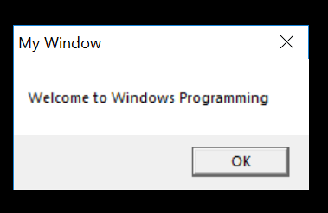

**Question.2**

Write a suitable CPP code for generating following output. It is a simple window that has been generated using windows programming constructs.

